**REST - Country Web Service** 

**Country.xml:**

<?xml version="1.0" encoding="UTF-8"?>

<beans xmlns="http://www.springframework.org/schema/beans"

xmlns:xsi="http://www.w3.org/2001/XMLSchema-instance"

xsi:schemaLocation="

http://www.springframework.org/schema/beans

http://www.springframework.org/schema/beans/spring-beans.xsd">

<bean id="in" class="com.cognizant.spring_learn.Country">

<property name="code" value="IN" />

<property name="name" value="India" />

</bean>

</beans>

**Country.java:**

**package** com.cognizant.spring_learn;

**public** **class** Country {

**private** String code;

**private** String name;

**public** Country() {

}

**public** Country(String code, String name) {

**this**.code = code;

**this**.name = name;

}

**public** String getCode() {

**return** code;

}

**public** **void** setCode(String code) {

**this**.code = code;

}

**public** String getName() {

**return** name;

}

**public** **void** setName(String name) {

**this**.name = name;

}

@Override

**public** String toString() {

**return** "Country [code=" + code + ", name=" + name + "]";

}

}

**CountryController.java:**

**package** com.cognizant.spring_learn.controller;

**import** com.cognizant.spring_learn.Country;

**import** org.slf4j.Logger;

**import** org.slf4j.LoggerFactory;

**import** org.springframework.context.ApplicationContext;

**import** org.springframework.context.support.ClassPathXmlApplicationContext;

**import** org.springframework.web.bind.annotation.RequestMapping;

**import** org.springframework.web.bind.annotation.RestController;

@RestController

**public** **class** CountryController {

**private** **static** **final** Logger ***LOGGER*** = LoggerFactory.*getLogger*(CountryController.**class**);

@RequestMapping("/country")

**public** Country getCountryIndia() {

***LOGGER***.info("START - getCountryIndia");

ApplicationContext context = **new** ClassPathXmlApplicationContext("country.xml");

Country india = (Country) context.getBean("in");

***LOGGER***.info("END - getCountryIndia");

**return** india;

}

}

**SpringLearnApplication.java:**

**package** com.cognizant.spring_learn;

**import** org.slf4j.Logger;

**import** org.slf4j.LoggerFactory;

**import** org.springframework.boot.SpringApplication;

**import** org.springframework.boot.autoconfigure.SpringBootApplication;

@SpringBootApplication

**public** **class** SpringLearnApplication {

**private** **static** **final** Logger ***LOGGER*** = LoggerFactory.*getLogger*(SpringLearnApplication.**class**);

**public** **static** **void** main(String[] args) {

***LOGGER***.info("Starting SpringLearnApplication...");

SpringApplication.*run*(SpringLearnApplication.**class**, args);

***LOGGER***.info("SpringLearnApplication started successfully.");

}

}

**OUTPUT:**

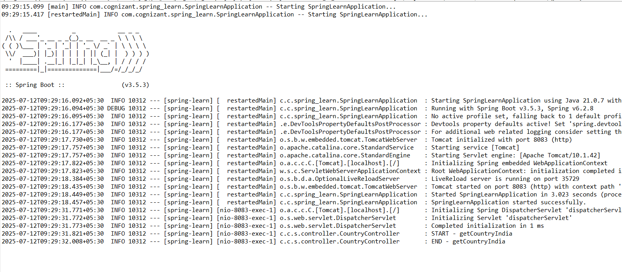

<http://localhost:8083/country>

